**Thank you**

**for Supporting Manchester Masonic Lodge # 148**

**The proceeds from this golf outing go back into our community to help local organizations, such as but not limited to:**

**After Prom Committee**

**Manchester Swine club**

**Manchester CRC**

**Senior Center**

**Manchester Historical Society**

**Manchester Robotics Team**

**Manchester Young Guns**

**American Legion Auxiliary**

**Kirk Park Renovations**

**Manchester Wrestling**

**Michigan Masonic Charities**

**Manchester Area Youth Sports**

**Manchester Family Services**

**Dutchman Firefighters Assoc**

**Golf Committee:**

**Patrick Conklin**

**Joe Jarvis**

**Guy Gilbert**

**Barry Allen**

**Ron Marecle**

**Kurtis Blumenauer**

 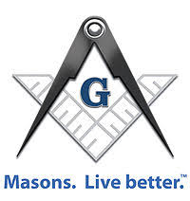

**9th Annual**

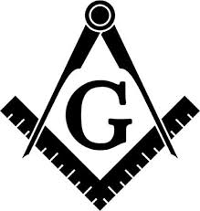

**Manchester M Masonic**

**Golf Outing**

**Saturday**

**August 12, 2023**

**Please join us for a fun filled day of golf, great food, prizes and hopefully good weather!**

**Prizes Include:**

* **First Place - $400**
* **Second Place - $200**
* **Closest to the pin**
* **Longest Drive/Putt**
* **Skins $20 per team**
* **50/50**
* **Raffle prizes & auction items**

**Date:** **Saturday August 12th**

**Location: Hill’s Heart of the Lakes**

**500 Case Rd**

**Brooklyn MI 49230**

**Time: Registration opens @ 8:00**

**Shotgun Start @ 9:00 am**

**Entry Fee: $75 Per Golfer/$300 per Team includes green fees, cart, lunch at the turn & dinner after golf.**

**Make checks payable to: Manchester Masonic Lodge**

**PO BOX 116**

**Manchester MI 48158**

**Format: Tournament format will be a best ball scramble consisting of 4-person teams; you can register as an individual and will be paired with a team.**

**Entry Form**

**Golfer 1: _______________________________**

**Golfer 2: _______________________________**

**Golfer 3: _______________________________**

**Golfer 4: _______________________________**

**Sponsors:**

* **Hole Sponsor $150**
* **Lunch Sponsor $250**
* **Gold Sponsor $1000**

**includes hole sign & dinner for 4, table at event and chance to speak at dinner**

**Please direct question to:**

**Patrick Conklin (734) 717 - 6535**

**Email: Patrick.Conklin@fbinsmi.com**

**Bob Blumenauer (734) 845 - 1265**

**Guy Gilbert (734) 255 - 3747**



**Cancelation Policy:**

1. **If outing is cancelled due to weather players will receive a refund**
2. **If player cancels 48 hrs prior to event they will receive 50% refund**
3. **“No Shows” are non-refundable**